CHALLENGE ON VPC ENDPOINT AND TRANSIT GATEWAY

Use Case: Setting up Transit Gateway and VPC Endpoints for a Multi-VPC Architecture
Scenario:

- A large organization is migrating its on-premises infrastructure to the AWS cloud.
- The organization's architecture involves multiple VPCs for different departments and applications, each requiring secure communication with centralized services and external resources.
- The IT team needs to design and implement a scalable and efficient network architecture to accommodate the organization's growth and ensure robust connectivity between VPCs and external services.

Objectives:

1.Design and deploy a scalable network architecture using AWS Transit Gateway to simplify network connectivity between multiple VPCs.

PURPOSE: The purpose of using an AWS Transit Gateway is to centrally connect and manage communication between multiple VPCs and on-premises networks without creating numerous individual peering connections.

OBJECTIVE: The objective is to create a centralized, scalable and efficient network topology that enables seamless communication betweeb multiple VPC s while reducing the complexity associated with VPC peering.

OUTCOME: A scalable and centralized AWS network architecture was successfully deployed using AWS Transit Gateway, enabling secure communication between multiple VPCs, simplifying network management, reducing peering complexity and providing a foundation for future growth and hybrid cloud connectivity.
STEP BY STEP IMPLEMENTATION:

- Create 3 VPCs, one will be public and remaining 2 are private
- I have attached Internet Gateway to the VPC that I wanted to be in public.
- So I have modified the routes in the route table with the Internet Gateway.

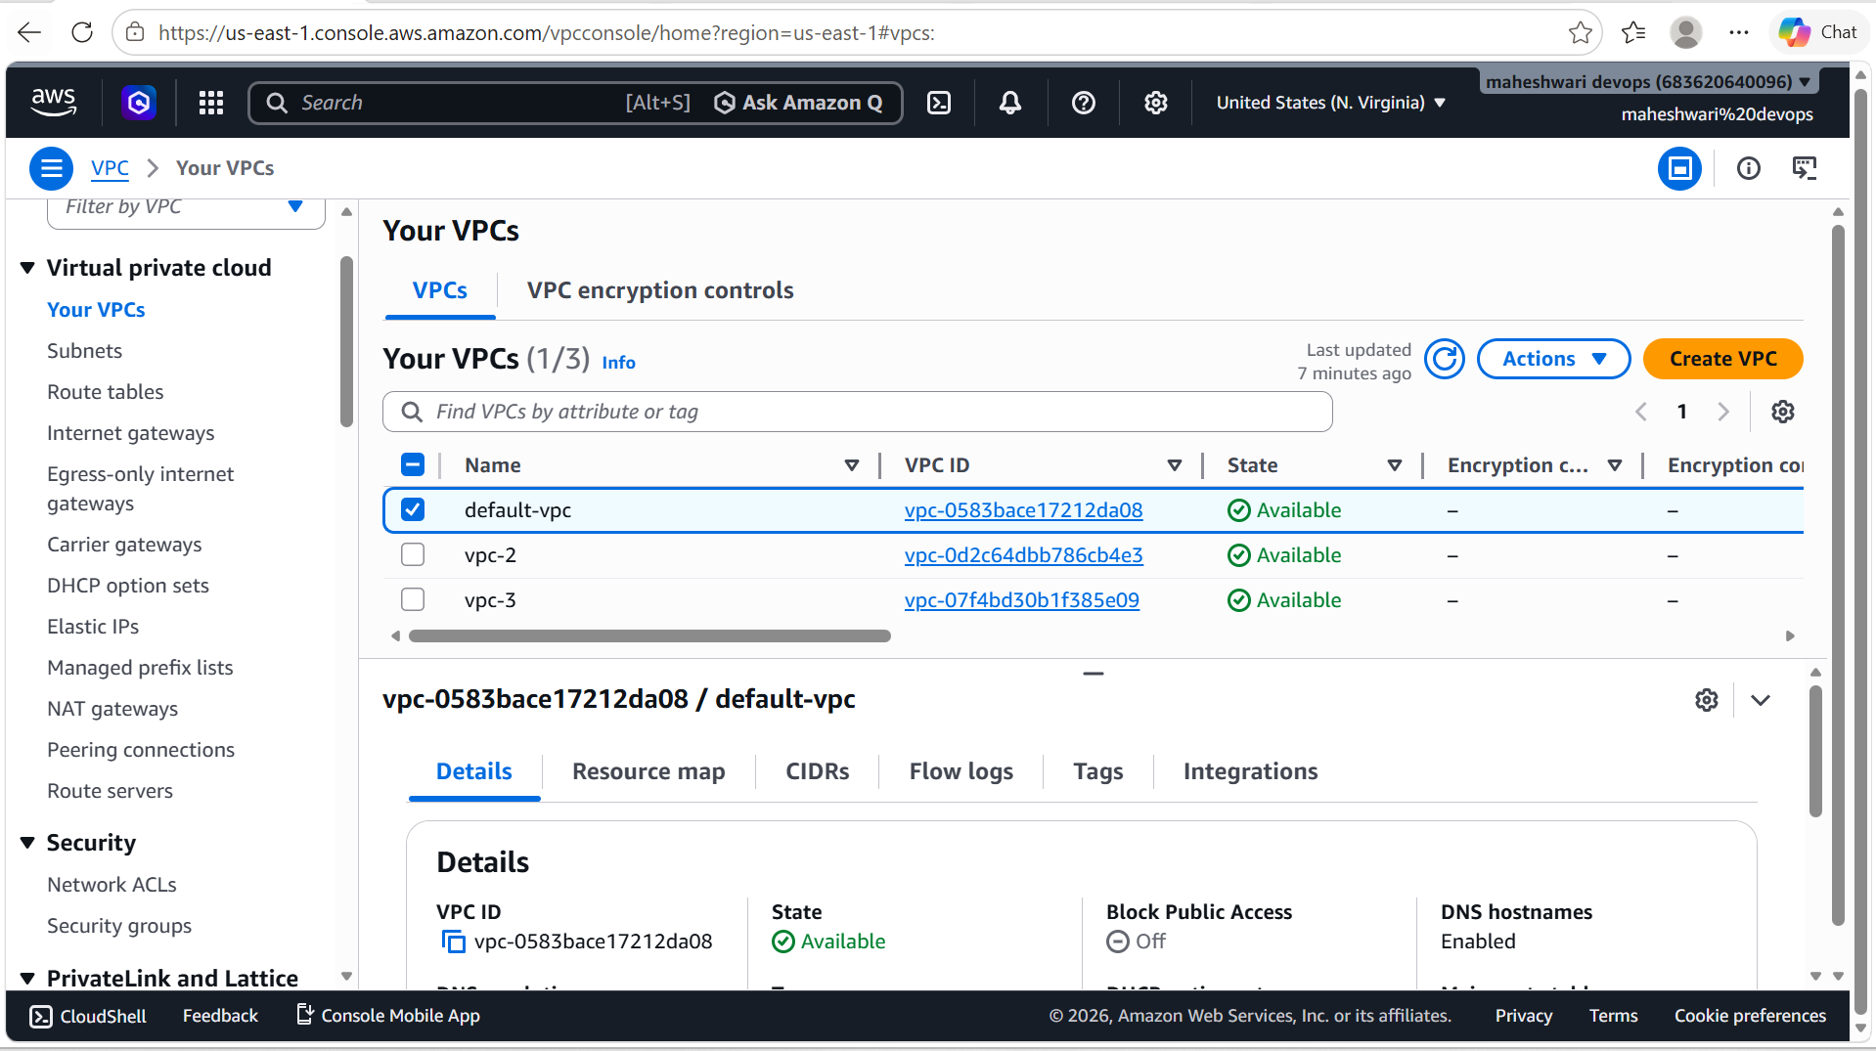

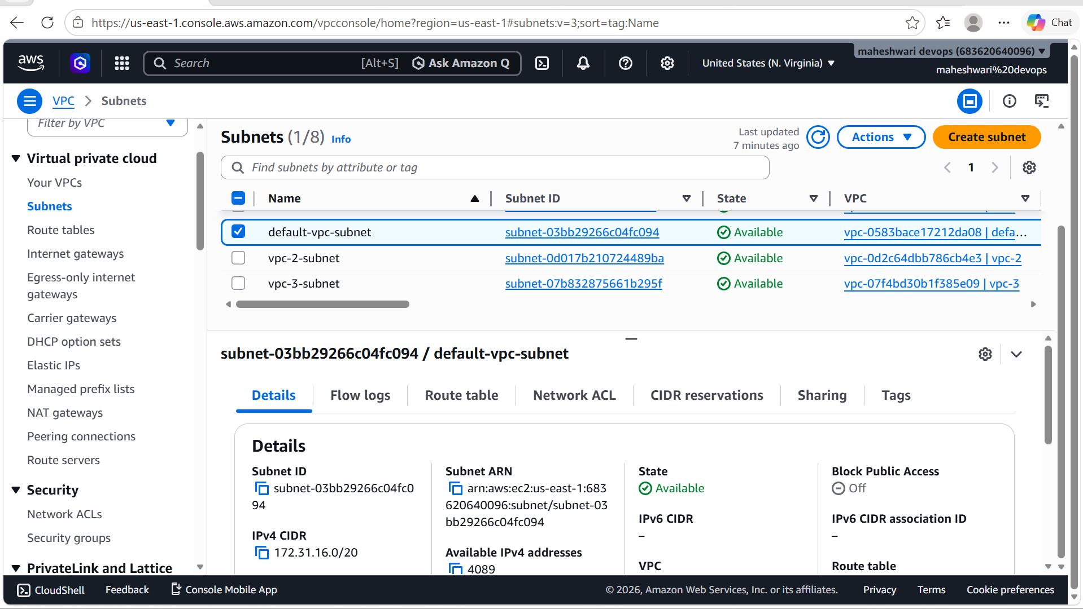
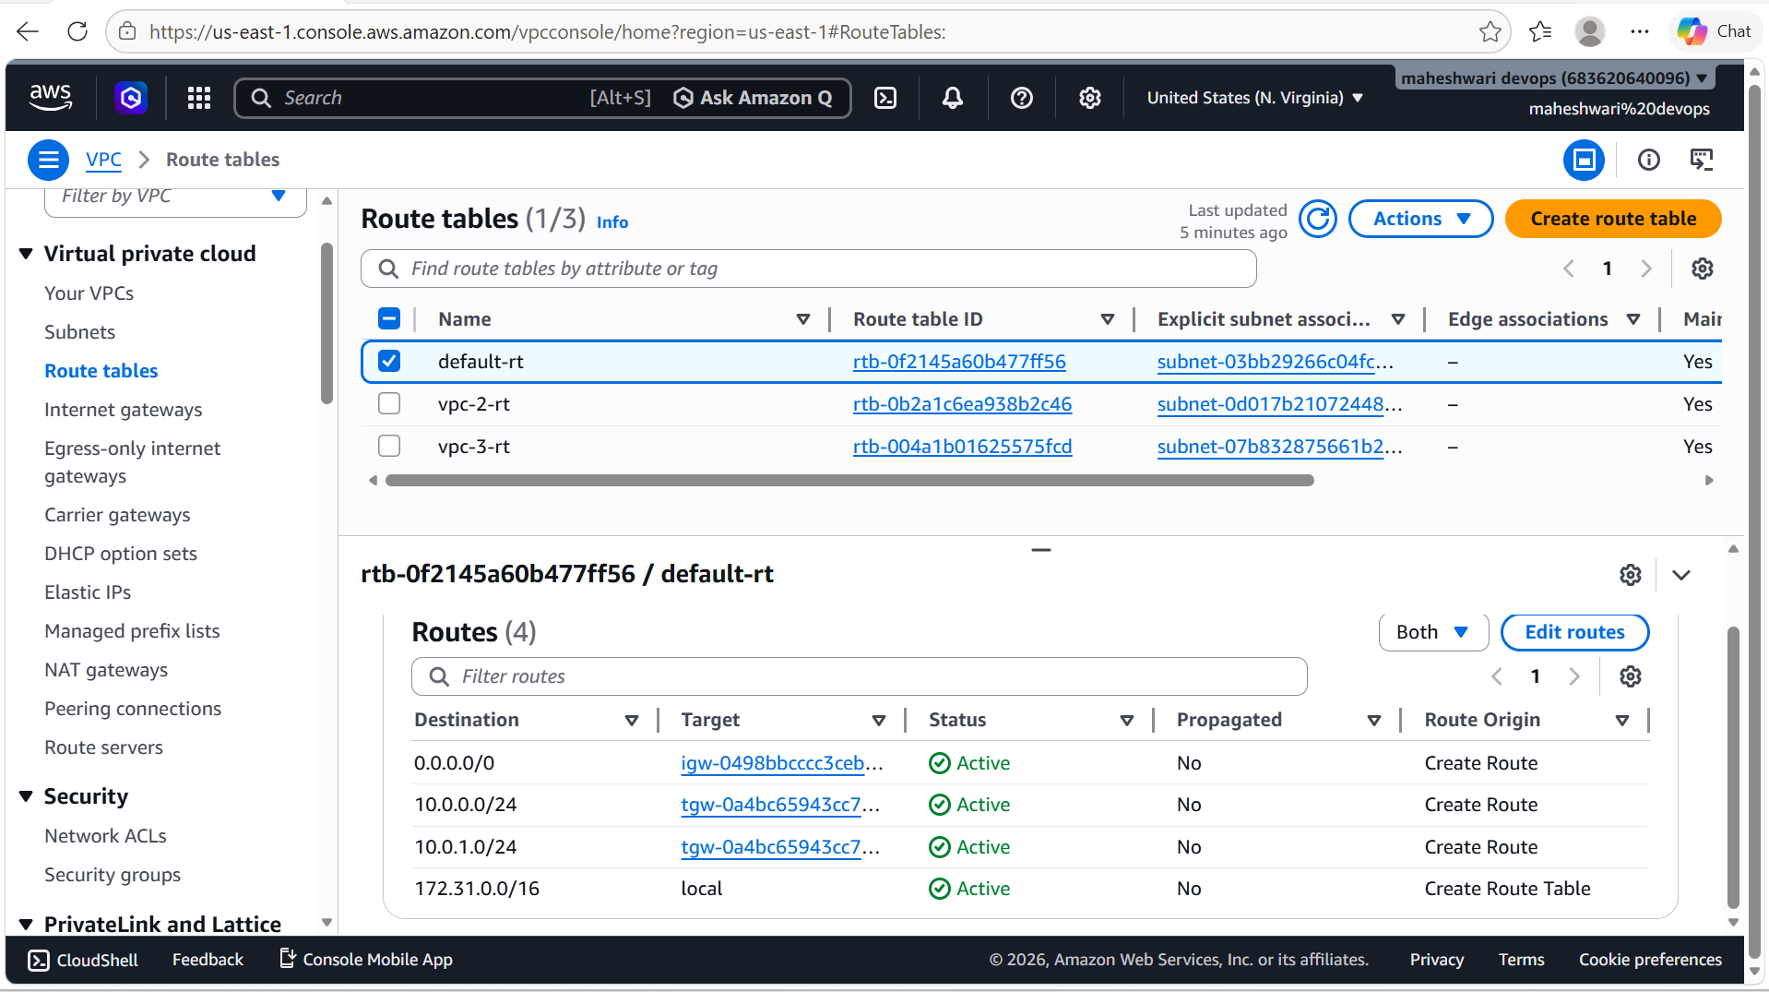

- Now I have created a transit gateway for the connection of VPCs that I have created.

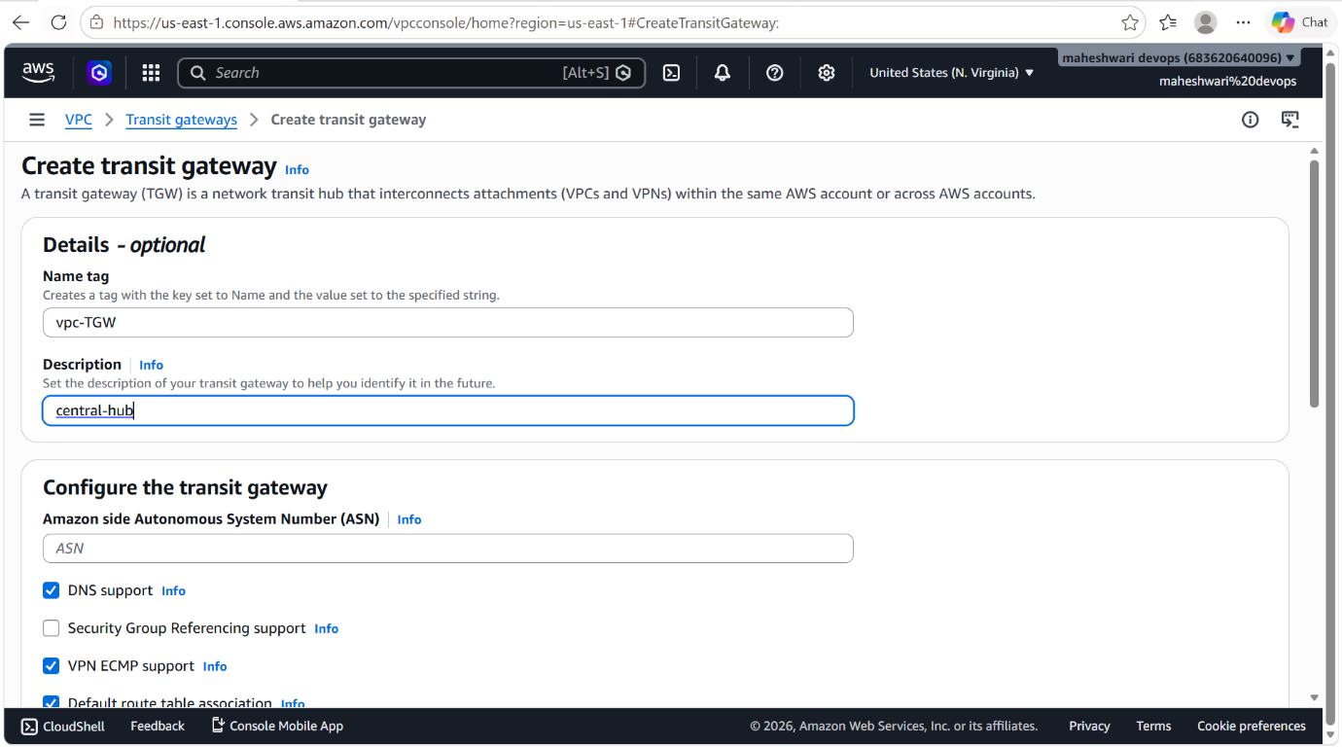

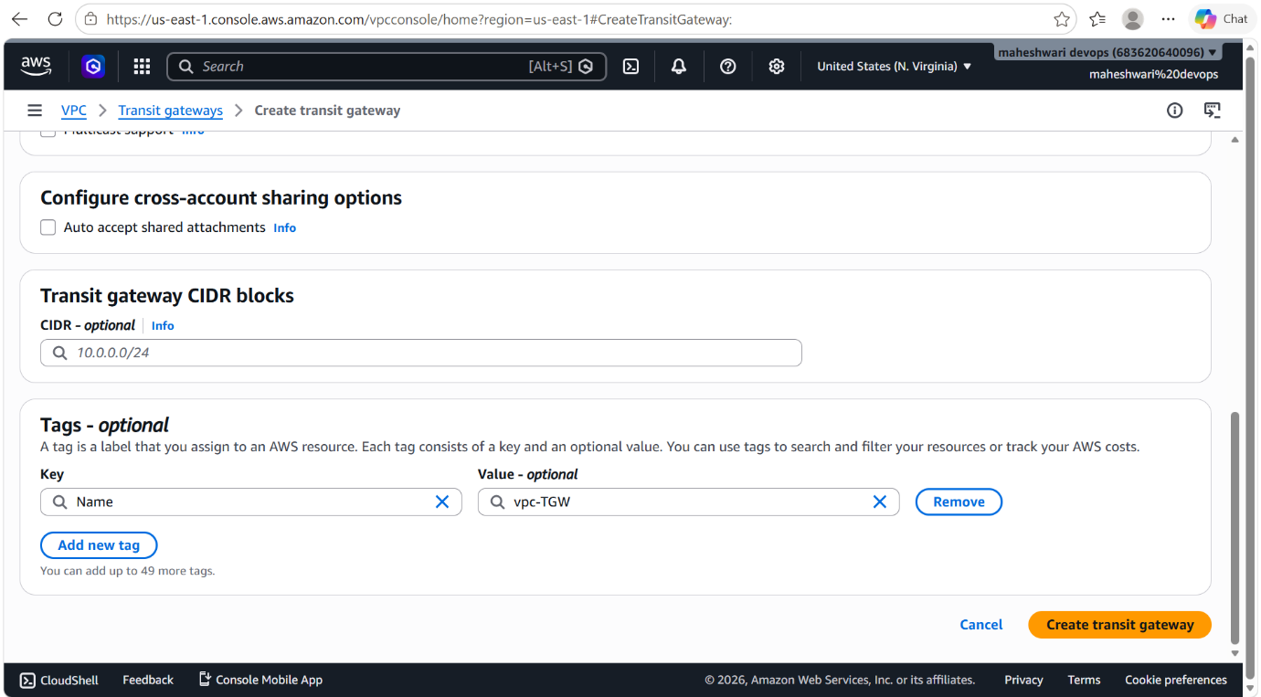

- after creating Transit Gateway, will have to create attachement between our VPCs and the Transit Gateway.
- For that in the navigation pane, go to Transit Gateway attachments.
- Create the attachments individually for every VPC

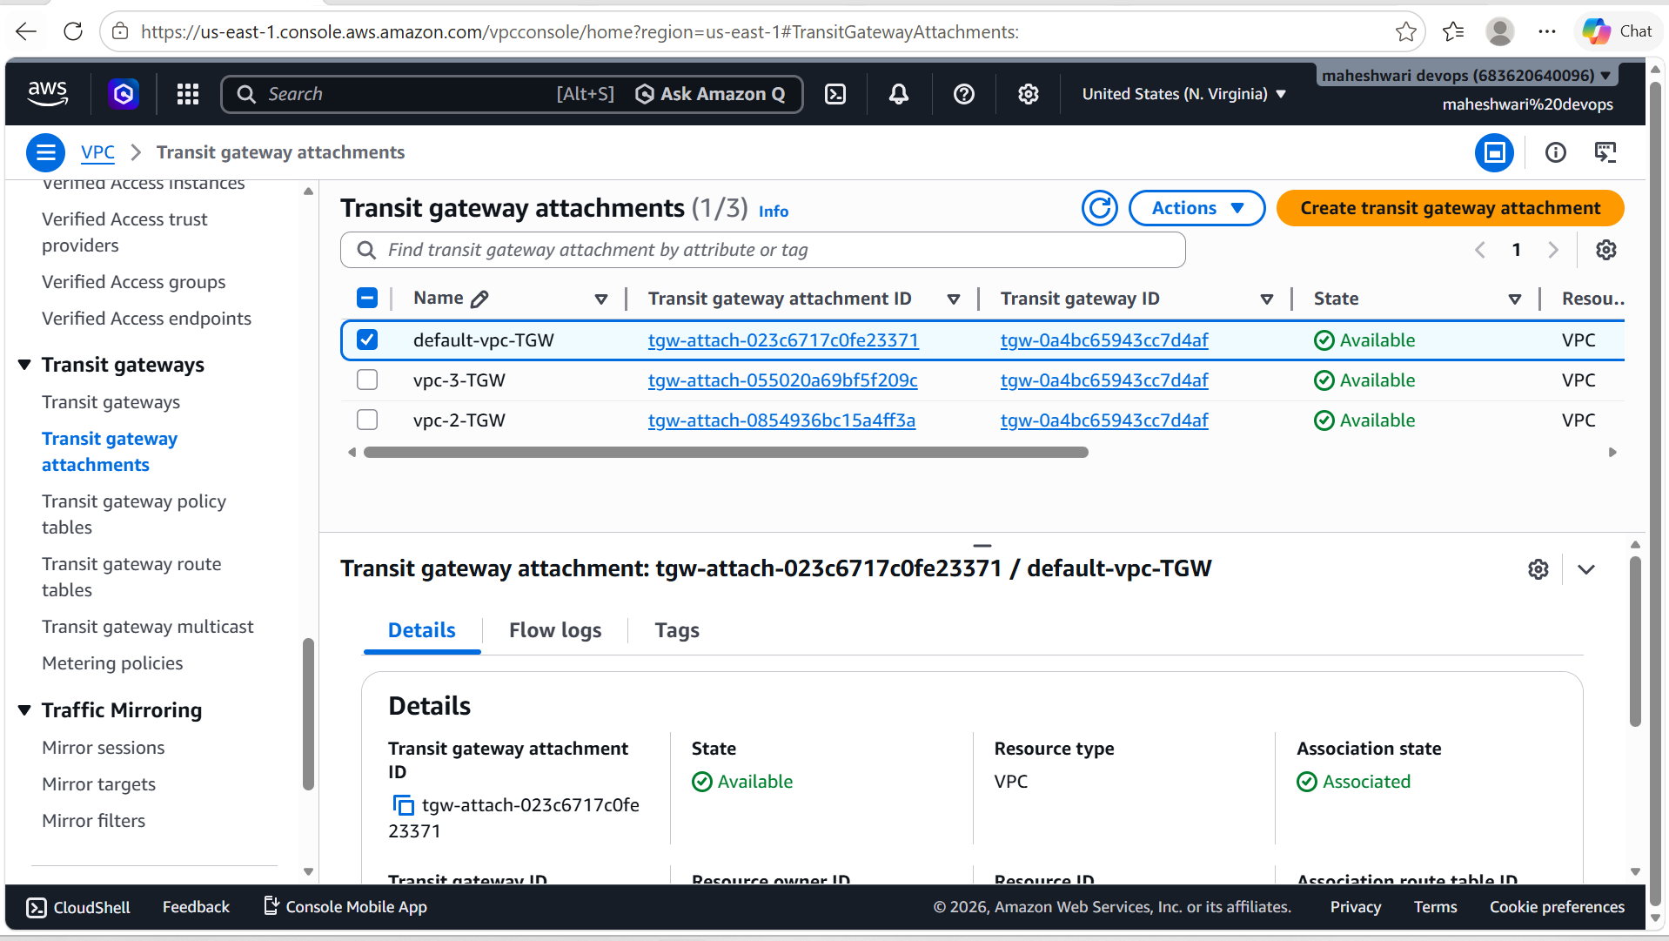

- Now check and verify the attachments in Transit Gateway route tables.
- This will be created by default when we have attached our VPCs to the Transit Gateway.

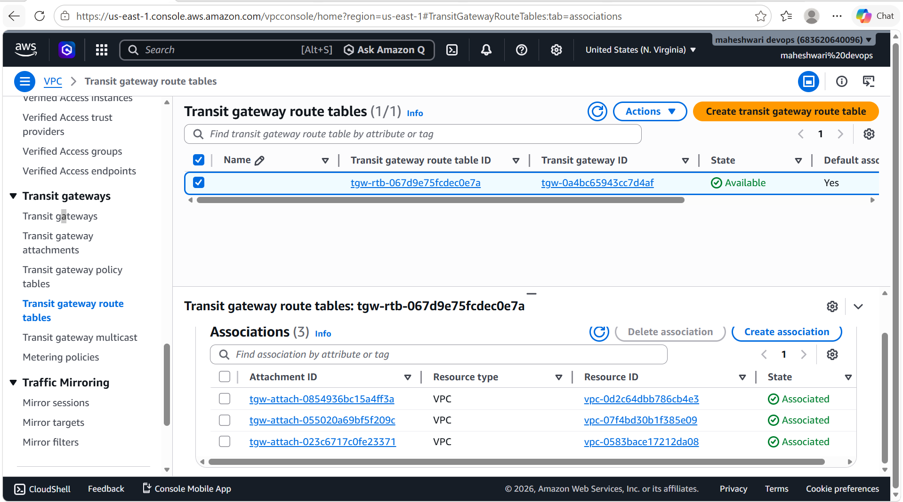

- Now in the route tables of each VPC, we have to edit the routes with the CIDR range of other VPCs that I have attached to the Transit Gateway.

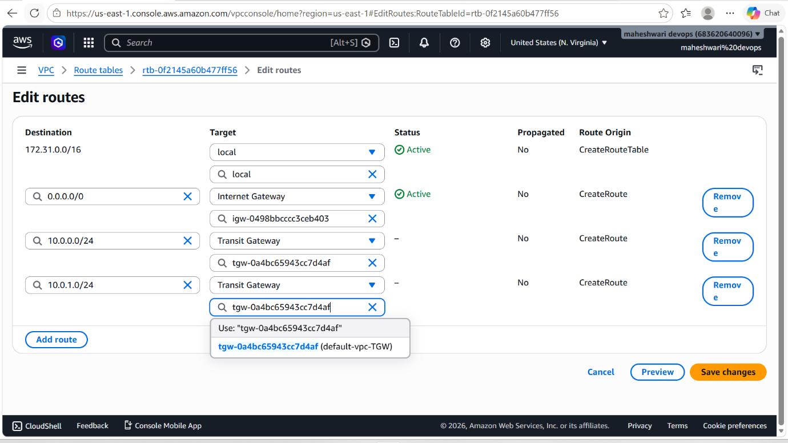

- Repeat this process, for every route table of every VPC.
- Now to check the connectivity between our VPCs, we have to launch instances in each VPC.

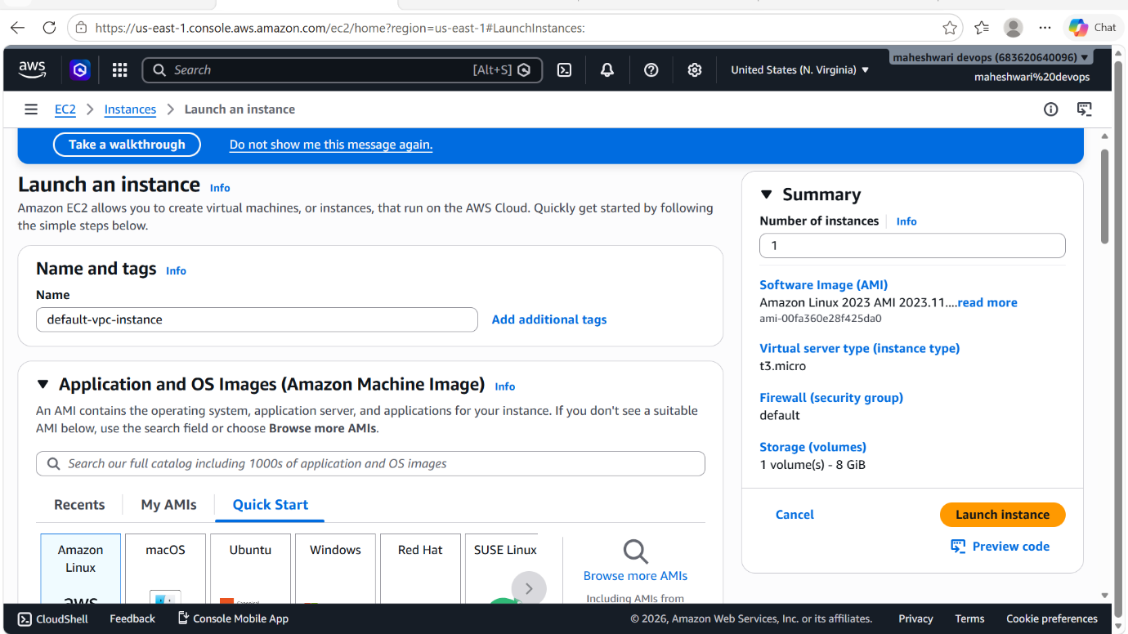

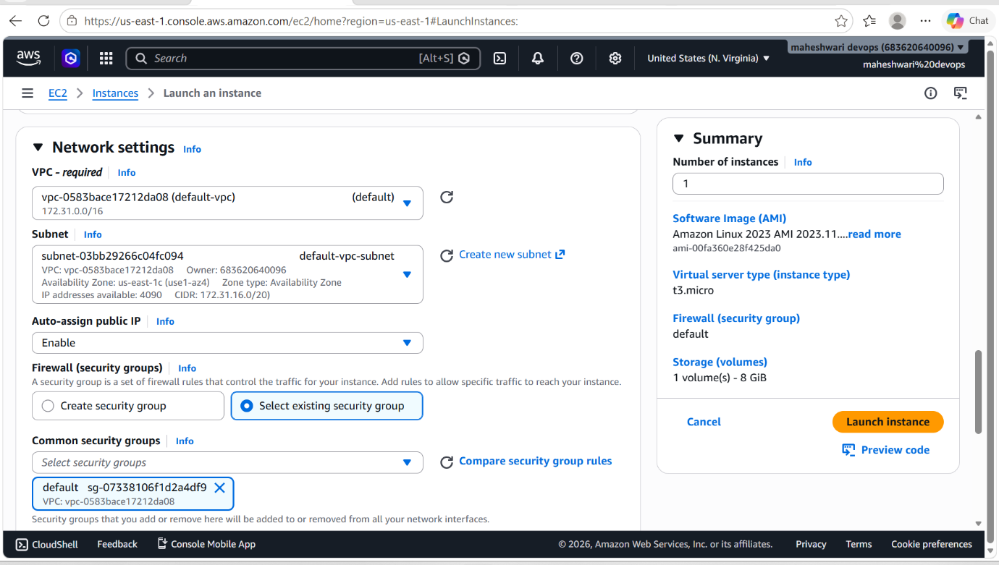

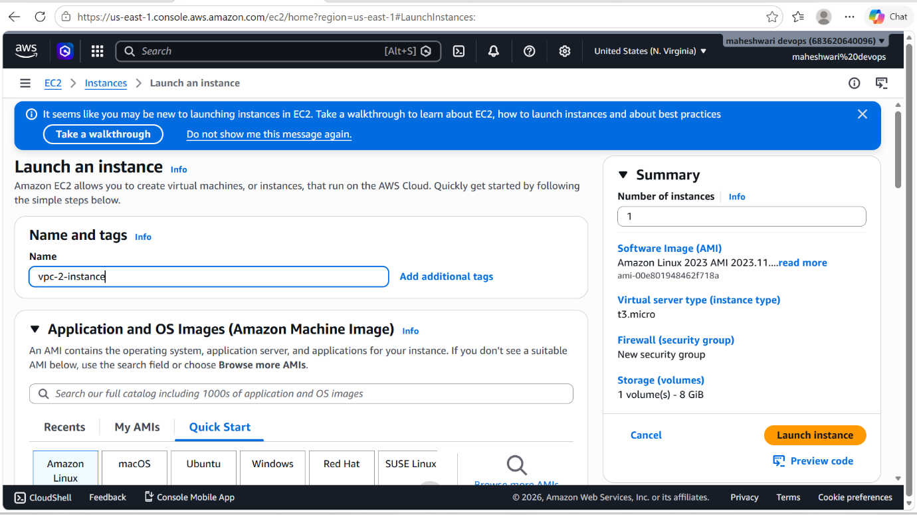

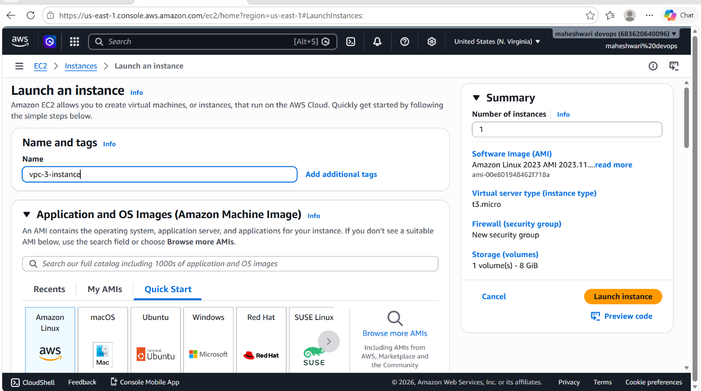

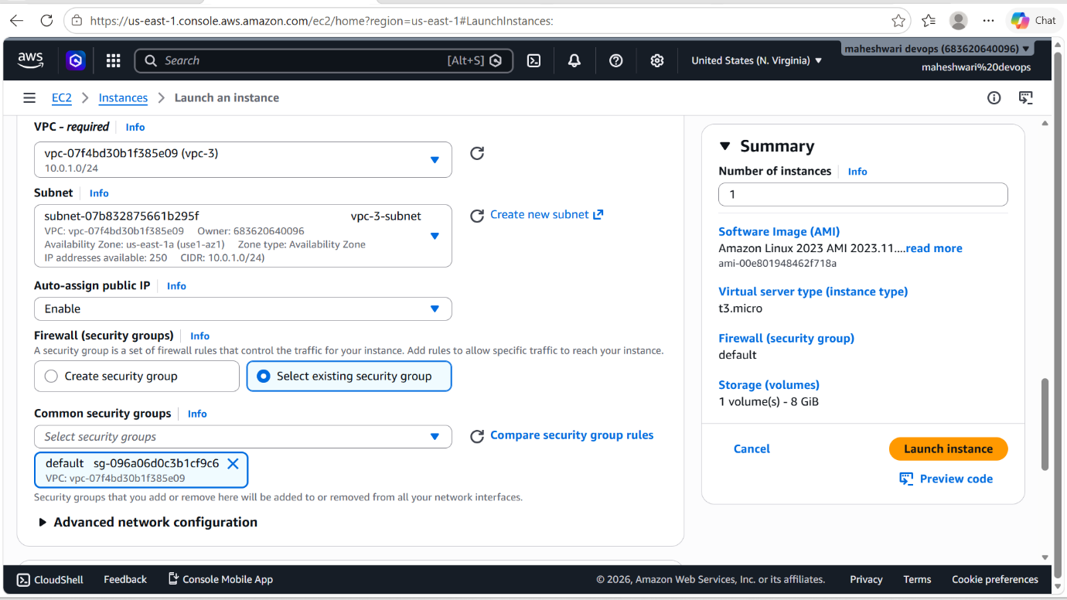

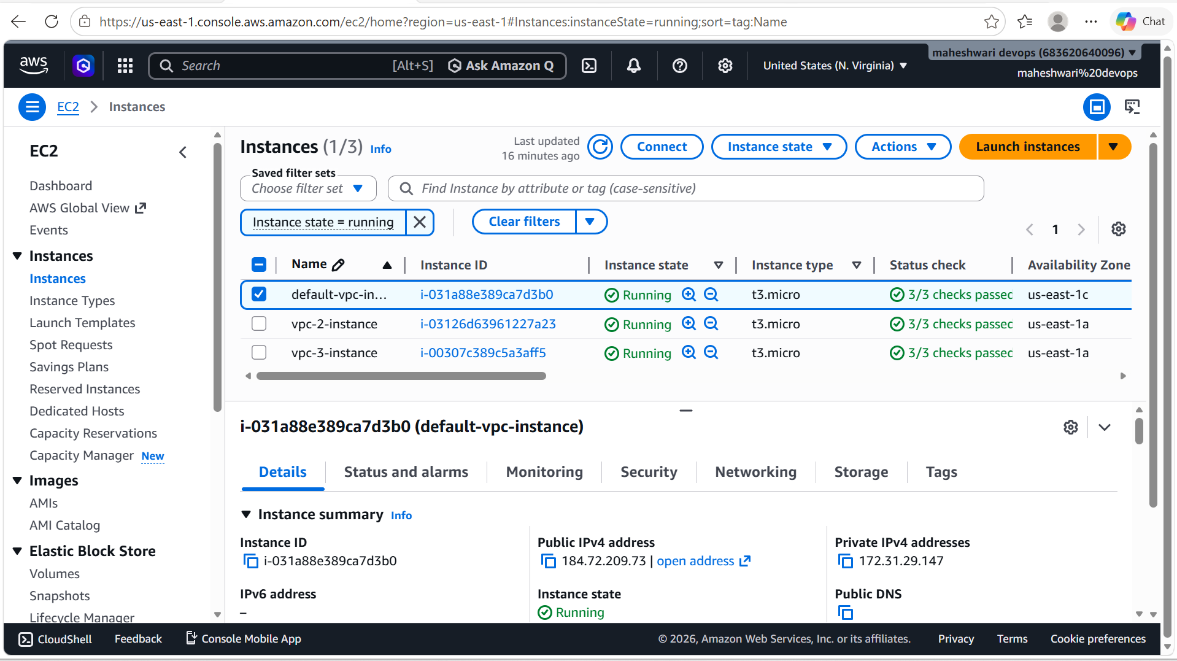

- Now to verify our Transit Gateway Attachement that we have made between VPCs, login ssh by using the public IP of public subnet.

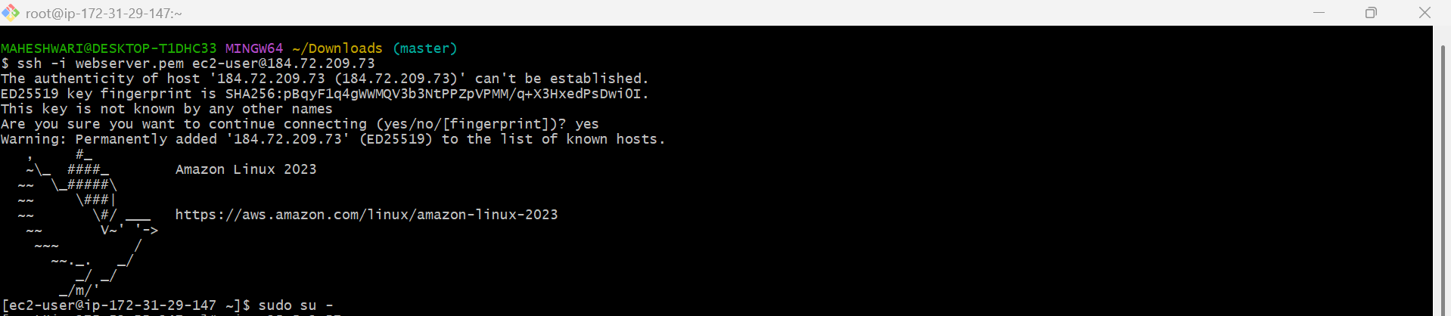

- Now check the connectivity with other instance, use ping <private-ip>

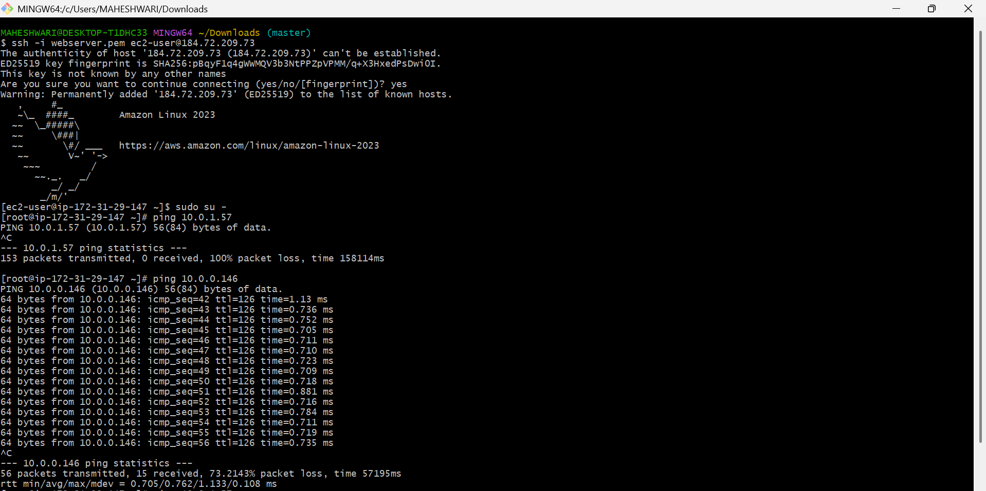

2.Configure VPC endpoints to securely access AWS services without internet gateways or NAT gateways, ensuring data privacy and minimizing exposure to external threats.

PURPOSE: To enable private connectivity between a VPC and AWS
Services without routing traffic through the internet, an internet gateway, a NAT gateway, or a VPN connection.

OBJECTIVE: To configure a VPC Endpoint that allows resources within a VPC to securely access AWS services using the AWS private network.
PREREQUISITES:
- An AWS account with appropriate permissions.
- An existing VPC.
- At least one subnet in the VPC.
- Route tables available for modification.
- A target AWS service (ex: Amazon S3 or DynamoDB).

TYPES OF VPC ENDPOINTS:

1.Gateway Endpoint:
Supported services:
- Amazon S3
- Amazon DynamoDB
2. Interface Endpoint:
Supported services:
- Amazon EC2 APIs
- AWS Systems Manager
- Amazon CloudWatch
- Many other AWS services.

OUTCOME: A VPC Endpoint provides secure and private access from a VPC to AWS Services such as Amazon S3 and DynamoDB without traversing the public internet.

STEP BY STEP IMPLEMENTATION:

Example: Create an S3 Gateway Endpoint
Step 1: Open the VPC Console
- Sign in to AWS.
- Navigate to VPC Dashboard.
- Select Endpoints.
- Click Create Endpoint.

Step 2: Select Service
- Service Category:
  - AWS Services
- Service Name: com.amazonaws.<region>.s3
Step 3: Select VPC
Choose:
- Your VPC (e.g., My-VPC)

Step 4: Select Route Tables
Choose the route tables associated with the subnets that require S3 access.
AWS automatically adds routes to the selected route tables.

Step 5: Configure Policy
Choose:
Full Access

Step 6: Create Endpoint
Click Create Endpoint.
The endpoint state should become Available.

Verify Configuration
From an EC2 instance inside the VPC:
-> aws s3 ls

